Customer Access Service Cabinet Committee on Performance Improvement Report

SUPPORTING THE COVID RESPONSE
Appendix 'C'

Version: | v 0.1
Date: | 08/02/2021
Owner(s): | Sarah Jenkins
Author(s): | Terry White

Table of Contents

1 Background 3

2 Supporting the Covid response 4

Having a chat 4

Community Hubs 4, 5

Excess Deaths 6

Blue Badge 6

Waste 7

Libraries 8

Registrars 8

Covid Testing 9
Covid Grants …………………………………………………………………………………………………………….…9
Care Capacity Tracker …………..………………………………………………………………………………..9,10
Vaccination Programme ………..……………………………………………………………………………….…10

Background

  - The Customer Access Service (CAS) is the first point of contact for approximately 30 council services, handling of over 1 million annual contacts across a range of channels. In addition, the service manages the administration of revenues and benefits for West Lancashire Borough Council and processes over 30,000 Blue Badge and Crisis Support applications each year.

  - In addition to maintaining our business as usual service, a key aim during the pandemic was to ensure we supported both internal and external services in responding to the crisis and proactively assisting the citizens of Lancashire in accessing whatever help and support they needed.

  - This report looks at the projects and initiatives that CAS have contributed towards since April 2020 and how those contributions have helped Lancashire's response to the pandemic.
2 Supporting the Covid Response

2.1 Having a chat
In order to fully support our customers we immediately introduced an extension to our service to 'check in' on people during the crisis. This initiative, dubbed "Having a chat" encouraged our advisors to take the time to talk to each caller outside of the remit of their request and understand how they were coping generally during the lockdown.

Our advisors were able to establish needs and signpost people to communities, charities or businesses that could help. We received a fantastic response from callers who felt like they were being listened to, being helped and most importantly, having a genuine, human conversation in what was an unsettling time for them.

The feedback from our staff was equally positive, with advisors feeling empowered and encouraged to go above and beyond for our customers during a time when they needed it the most.

Example: "I have just spoken to a lady on the Cashiers line to pay an invoice. We got into a discussion about how she was feeling and she started telling me that she has really bad arthritis in her hands and can't hold things properly so she's struggling with food. She's been using a taxi firm to get her shopping so I called through to the Wyre Community Hub and got them to arrange for a volunteer to do her shopping list with her and collect what she needs.
When I called her back to inform her of this she got upset and then started to tell me about how she wasn't coping generally. Before the pandemic she was being transferred to a care home but had to stay at home as they couldn’t move her due to the current situation. I called through to Sue in our Social Care section and she's going to arrange for an urgent assessment to increase her care and get some occupational therapy.
I've cried twice since which isn’t like me. She said that God had answered her prayers and sent her an angel. It broke my heart."
Nicola Crookston. Customer Service Advisor. CAS
Example 1: Having a chat

2.2 Community Hubs
As a central point of contact for everyone within Lancashire it was essential that at CAS, we both understood and utilised the wide network of support available. Initiating contact with the community hubs as they were being formed, we facilitated weekly meetings to share best practise and act as a forum for advice, bringing together the 14 hub leads along with representatives from Our Lancashire, the Lancashire Volunteer Partnership, Integrated Voluntary Services and Lancashire County Council's Public Health team.

During the initial lockdown we were able to utilise the hubs to ensure our customers, including the critically extremely vulnerable citizens who were shielding, received the support they needed.

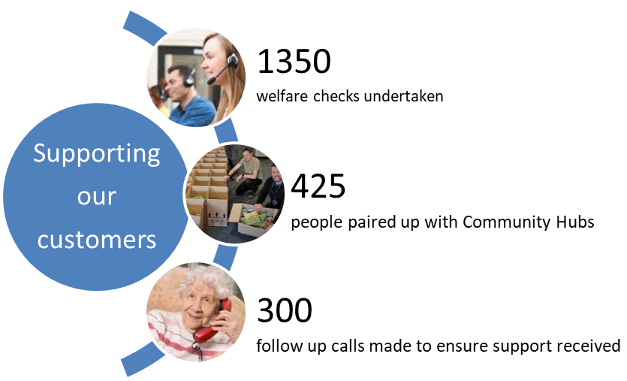
Fig 1: Supporting our customers

Although referrals to the community hubs decreased following the initial surge we continued to play a pivotal role in the response and were subsequently asked by the Humanitarian Assistance Cell (HAC) to chair the Community Hubs and Shielding sub cell which, along with Homeless and Faith sector sub cells, supports the Community Recovery Group.

The work undertaken with the Community Hubs will be built upon and expanded to fully embed Adult Social Care's Demand Management strategy. Although it is possible that the Community Hubs will be disbanded once the crisis has abated, significant work has been undertaken in CAS to build a directory of over 300 community resources within Lancashire, ranging from Befriending services to Learning opportunities. In addition to this we are working with Our Lancashire to look at pooling our information and using their website as a single point of information for services in Lancashire.

Fully utilising the community resources available and identifying gaps for services to be commissioned in specific areas will be a key step in reducing the cost of Adult Social Care in Lancashire.
2.3 Excess deaths
Responding to the impact COVID-19 had within Lancashire, we worked with the Coroners Service in managing the response to excess deaths within the community.

Our Business Development Team mapped out the process for both the reporting of deaths in the community resulting from COVID-19 and the sourcing of support to transport the deceased to either a funeral home or into the emergency temporary storage facility created at BAE systems in Warton

System configuration, guidance, testing and training for both CAS staff and LCC volunteers were undertaken to ensure the provision of a 24 hour first point of contact for General Practitioners throughout Lancashire. With the impact of COVID-19 receding following the initial lockdown this service is currently on hold but with the authority still on alert, provisions are in place for it to be re-installed within 48 hours should the county see a further spike in deaths.
Fig 2: Excess Deaths Process
CAS involvement brought benefits including access to our telephony platform, detailed reporting functionality and the in-house skills / experience required to pull the different project strands together.

2.4 Blue Badge
With the lockdown restricting movement for residents who were shielding we introduced immediate amendments to the application process for Blue Badges. These allowed customers to receive a badge without having to post proof of identity or residency and in addition, we ceased face to face assessments in order to keep our customers safe, issuing temporary badges instead until the restrictions eased.

In November 2020 we introduced the Department for Work and Pensions Searchlight system within our Blue Badge Team, which allowed us to obtain benefit information without customers needing to provide proof of their awards. With this affecting 45% of all applications, it will have a wide-reaching effect on our citizens, making the application process easier and the timescales for receiving a badge shorter.

2.5 Waste
Following their initial closure, the majority of Lancashire Household Waste Recycling Centres reopened in May 2020 allowing residents to visit Recycling Centres using an appointment system.

CAS contributed towards the specifications and testing of the system as well as providing ongoing feedback on both the system and online content for customers.

Following the reopening we answered over 25,000 calls for the Waste service, an increase of 240% from the previous year. The project has demonstrated the versatility of our advisors in adapting to change and delivering a service in a completely different way.

With the pandemic still having an impact on how our customers use this service we will be targeting the Waste page on the Lancashire County Council website to deploy our Webchat channel. This will allow us to assist citizens in quickly accessing information and using the online booking system.

Fig 3: Waste calls

2.6 Libraries
This initiative is one of many that have been promoted during our fortnightly meetings with the Community Hubs. LDA, The Carers Service and Virgin Care have also had guest speakers attend to promote their services.
During 2020 the Libraries Service were involved in a government supported project which is aimed at connecting the unconnected. The project provided digital devices free of charge, along with internet connection to vulnerable and elderly customers. It ensured customers had access to accurate health information online, were able to stay socially connected and interact with both medical support and essential services. CAS have been supporting the initiative by managing customer queries and liaising with Libraries to troubleshoot issues.

We also supported the service in testing and implementing a booking system, providing telephony support to customers which allowed them to access their libraries safely and order books through the Browse and Borrow and 6 of the Best initiatives.

2.7 Registrars
Throughout the initial lockdown CAS worked with the Registration Service on their recovery plan to reopen birth registrations. These had been unavailable to customers since the implementation of lockdown and had generated a backlog of outstanding registrations in Lancashire. Our Business Development Team helped the service to design a new two-part registration process that supported social distancing measures with an initial telephone appointment being made followed by a face to face meeting to sign the register.

We answered over 23,000 calls for the Registration Service between April and August, an increase of 30% during the same period in the previous year. We also contacted over 6000 customers to book appointments for notifications of birth, clearing 72% of the backlog that had built up since the commencement of lockdown.

Fig 4: Registrars calls
2.8 Covid Testing
During the early summer CAS worked closely with Lancashire County Council's Public Health Team to take over the first point of contact for the Testing Hub. This went live on 11th June 2020 and alleviated the resource pressures on the service as the facility was made available to additional sectors. Our Business Development Team subsequently reviewed and improved the process, generating greater efficiency and ability to cope with the increase in volumes.

With Lancashire County Council initiating community testing CAS took responsibility for the Test Notifications, providing an essential element in managing the increase in Covid cases throughout the county. We sent over 35,000 Covid Test Notifications to Lancashire residents and took ownership of Warn and Inform notifications following outbreaks, advising people to self-isolate where necessary.

2.9 Covid Grants Scheme
In June 2020 CAS began work on the BoostYourRecovery campaign, assisting the Economic Development Team in helping Lancashire enterprises reset and plan their return from lockdown. The campaign, launched on the first day of lockdown, has assisted more than 7000 Lancashire businesses.

Under the umbrella of the Boost ERDF project the Business Growth and Innovation service set up and implemented a small capital grants programme to support Lancashire SMEs in their response to the impact of Covid. CAS supported the team in the review of over 1,000 expressions of interest and the issuing of over 500 application forms to eligible businesses in Lancashire. CAS are continuing to support the campaign and to date have processed 325 Business Grant applications and 270 state aid letters.

Example: "You and your team have done a fantastic job and it is a very important and valuable contribution to the Covid grants scheme. With your help we can now run reports, track grant awards and progress on the scheme much more easily. A huge thank you to the team."
Darshana Patel. Compliance and Finance. Lancashire County Council
Example 2: Covid Grants Scheme

2.10 Care Capacity Tracker
From September 2020 CAS have assisted Adult Social Care in supporting the Lancashire care sector during the pandemic. We make daily calls 7 days a week to over 700 care and support providers, including residential care homes, domiciliary services and supported living. By building relationships with each provider and collecting essential data from them we have been able to support the continued delivery of services, keeping staff safe and able to work.

The data we collect provides the authority with insight into a range of areas including PPE stock, suspected and confirmed Covid cases amongst both staff and service users and their general confidence to operate in the immediate future. This allows our Contracts team to assess the countywide situation and provide additional, more localised, support to the providers who need it.

Since the start of 2021 we have also worked with the care providers to understand vaccination levels within care home staff. This has proven invaluable to the authority in establishing any areas of, and reasons for, low take-up to allow targeted work that will ensure maximum update of the vaccine across Lancashire.

2.11 Vaccination programme
Since December 2020 CAS have provided ongoing support to Lancashire Teaching Hospitals in booking Covid vaccinations for front line Health and Social Care staff. This has included hospital, care home and social work staff and has expanded to cover all areas of the county.

Approximately 4000 vaccination bookings have been made and our team are currently conducting an exercise across Lancashire County Council to define levels of uptake among staff and maximise uptake by highlighting any areas of concern.

Our staff have answered over 5000 vaccine enquiry calls and CAS has now become a centralised point of contact for all frontline Social Care Workers and Personal Assistants in Lancashire that need support in booking a vaccination.

Example: "I would like to thank you and your extraordinary team for all for the invaluable work you have been doing with Lancashire Teaching Hospitals NHS Foundation Trust. Through cross-collaboration with Lancashire County Council, we have pooled our resources, knowledge and expertise at what we do best to cast a wider net and contact the essential and most at risk.
I still recall when we first made contact with yourselves, the speed at which your team responded and provided a workable solution was absolutely incredible. With your crucial help and support, we continue to capture and vaccinate the vulnerable and high-risk cohorts of people. Therefore, it goes without saying that you and your team have contributed to the immunisation of various communities, in order to gain the protection they need against such a destructive disease. I hope you too feel the significance and magnitude of positive impact that you have had to this emergency both Nationally and Regionally. I hope that we continue to work together and share our aim to safeguard our professional communities and families, and like you, I also hope to see an end to this pandemic.
I believe our joint effort could potentially open up many avenues in realising the aims and values of both Lancashire County Council and Lancashire Teaching Hospitals in delivering the care services needed by the Lancashire Community".
Venkata Padala. Head of Enterprise Wide Applications. Lancashire Teaching Hospitals
Example 3: Vaccination programme

